A Project Report
On
ANDROID APPLICATION ON VEHICLE DIAGNOSTICS AND PERFORMANCE ANALYSIS

Submitted to
Amity University, Uttar Pradesh

In partial fulfilment of the requirements for the award of
the degree of Bachelor of Technology In
Computer Science and Engineering By
Pranay kumar and divyansh bhatnagar
Under the guidance of
Mrs. shilpi gupta
Department of Computer Science & Engineering
Amity School of Engineering and Technology
Amity University
Noida, Uttar Pradesh
MAY 2015
DECLARATION

We, Pranay Kumar and Divyansh Bhatnagar, students of B.Tech (Computer Science and Engineering) hereby declare that the project titled “Android Application on Vehicle Diagnostics and Performance analysis” which is submitted by us to the Department of Computer Science and Engineering, Amity School of Engineering and Technology, Amity University, Uttar Pradesh, Noida, in partial fulfillment of requirement for the award of the degree of Bachelor of Technology in Computer Science and Technology, has not been previously formed the basis for the award of any degree, diploma or other similar title or recognition.

Noida

Date: Name and Signature of Students

CERTIFICATE

On the basis of declaration submitted by Pranay Kumar and Divyansh Bhatnagar, students of B.Tech (Computer Science and Engineering), I hereby certify that the project titled “Android Application on Vehicle Diagnostics and Performance analysis” which is submitted to the Department of Information Technology, Amity School of Engineering and Technology, Amity University Uttar Pradesh, Noida, in partial fulfillment of the requirement for the award of the degree of Bachelor of Technology in Information Technology, is an original contribution with existing knowledge and faithful record of work carried out by them under my guidance and supervision.
To the best of my knowledge this work has not been submitted in part or full for any degree or diploma to this University or elsewhere.
Noida

Date: Mrs Shilpi Gupta
Department of CSE
ASET, AUUP
NOIDA

ACKNOWLEDGEMENT
I would like to express my gratitude to all those who gave me the possibility to complete this project. Firstly I would like to express my gratitude to the senior authorities, Dr Ashok Chauhan and Dr. Balvinder Shukla for giving me the permission to commence with my project and encouraging selection of new, innovative topics. I would also like to thank Dr. Abhay Bansal, HOD Computer Science, ASET for giving opportunity to have this project and Major Project as a part of our curriculum.
I am thankful to Amity University for providing us with a Major Project. I would also like to thank my Faculty guide Mrs Shilpi Gupta for constant guide force throughout the course of the project and whose immense support and cooperation has made the completion of this project possible. Their suggestions with regards to the project and the methodology were of immense help.
The compilation of the subject matter for the project report always involves a creation of huge debt towards faculties and mentors. I hereby put my sincere thanks to one and all.

ABSTRACT
The main aim of this project is to develop an application for the android operating platform which would enable the user to connect to the ECU of their cars using an OBD-II connector port that is present in all modern day cars. This would enable the user to check their own car for fault codes or any errors themselves rather than taking their car to a specialst. This would reduce ownership costs to a great extent as one would bypass the need for specialist equipment for vehicle diagnostics.
The term On-boardediagnostics (OBD) is aneautomotive term whicherefers to a vehicle's self-diagnostic andereporting capability. On-Board Diagnostic systems give the vehicle owner access to all the various systems of a car.
This application will provide the ability to see what a particular vehicle is doing inerealtime, Lookup of OBDefault codes, careperformance,speed timings, sensor data and more.
This application uses an OBD-II Bluetooth adapter to connect to OBD2 port present in the car which would connect to the cars ECU
This application can also showeand reset a fault code like a scantool. This helps youefix your car and helpsekeep repair costsedown.

TABLE OF CONTENTS

DECLARATION I
CERTIFICATE II
ACKNOWLEDGEMENT III
ABSTRACT IV
TABLE OF CONTENTS V
LIST OF FIGURES VI
CHAPTER 1: INTRODUCTION 3
  - What is the main purpose of the project? 3
  - Project Objectives 4
  - Scope 4

CHAPTER 2: LITERATURE REVIEW 5
  - Relavant Studies on OBD-II 6
  - Modes Of Operation 9

CHAPTER 3: PROJECT DESIGN AND IMPLEMENTATION 10
  - Project Budget 10

APPROACH TO DESIGN 11
3.2 Andoid Software Development Kit 11
3.3 OBD-II 12
3.4 OBD-II Bluetooth Adapter 13
3.4.1 Where did it originated from? 13
3.4.2 Why do we need it? 14
3.4.3 ‘Check Engine Light’ 14
3.4.4 OBD-II and your auto’s wellbeing 14
3.4.5 OBD-II and execution tuning 15

3.5 THE ELM327 PROTOCOL 15
3.6 Project Roles And Responsibilities 16

CHAPTER 4: SIMULATION AND EXPERIMENTATION 17
4.1 Read OBD data through Bluetooth 17
4.2 Provide real time driving behavior information 17

RESULTS 28
CONCLUSION 35
FUTURE PROSPECTS 37
REFERENCES 39
APPENDIX

LIST OF FIGURES

CHAPTER 2: LITERATURE REVIEW
Figure 1.1 OBD-II Connector Port 7
Figure 1.2 Diagnostic Connector 8
CHAPTER 3: PROJECT DESIGN AND IMPLEMENTATION
Figure 2.1 OBD-II Port In Vehicle 12
Figure 2.2 OBD-II Port Layout 12
Figure 2.3 OBD-II Adapter 13
CHAPTER 4: SIMULATION AND EXPERIMENTATION
Figure 3.1 Bluetooth Connectivity 23
Figure 3.2 Open OBD Reader 24
Figure 3.3 User Interface 25
Figure 3.4 Connect a device 26
Figure 3.5 Settings Menu 27
RESULTS
Figure 4.1 Live Vehicle Data 34

CHAPTER 1: INTRODUCTION

1.1 What is the main purpose of the project?
Monitoring data from the OBD II arrangement was primarily projected to monitor engine emissions and to recognize the setbacks that provoked the cars pollute extra than normal. Today, though, manufacturers have increased the average to encompass a colossal number of data concerning setbacks and performance. OBD II data is provoking the "Check Engine" light on your car to go to after there is a setback, and it is your technician instrument early after the car is returned alongside symptoms that have no seeming cause.
Since the presentation and content of the data are uniform, a number of third party packages have been industrialized to notice and display these codes. A little of these mechanisms are related to a laptop, that way you can discern and catpure data.
This Module of the application intends to provide the user with full capability of viewing the realtime performance of their cars and monitor all crucial aspects of a drive.The phone can futher be mounted to the windsheild to provide utility of many of the guages that are not present in cars. “
The OBD systems are in almost all cars and light trucks on the road today. In the late 1970s and early 1980's various car manufacturers began the use of electronic means to control most engine functions and diagnose engine problems. This was done to primarily to meet Environmental Protection Ageny emission standards. Over the years OBD systems have become more and more complex. OBD-II is a new standard which was introduced in the mid-1990s. This standard provides almost complete engine control and also monitors various parts of the chassis, the body and most accessory devices, as well as the complete diagnostic control network of the car.”
The read-out diagnostics utilized by the technicians of the dealers are additionally elucidate via OBD II connector, but not portion of the EPA OBD II standard. The assorted codes Service / error display assorted data pulse width, hit the sensor procedure, wrecks of individual cylinders, combustion voltage condition and ABS brake transmission shift points. Over 300 readings could be obtainable, reliant on the producer and ideal of the vehicle and the sensor number used. All vehicles vary in the number of readings that they will support. OBD scanners can vary considerably in stride. signals they can read. A little could plainly display the frank OBD or OBD II signals, others could display the maximum scope of ability codes.

1.2 PROJECT OBJECTIVES

- Successfully make a reliable Android Application on Vehicle Diagnostics and Performance Analysis.
- Learn advanced features of Android Application development and Vehicle diagnostics.
- Learn the concepts involved with OBD-II connectivity and utilization.

1.3 SCOPE
The scope of the application is to incorporate the following features:
- Speed (OBD )
- Turbo Boost / Vaccum-
- Can read Engine coolant temperatures
- Throttle postion
- RPM data
- Timing Advance
- Realtime speed
- Direction of heading
- Fault code lookup
- Fuel Pressure
- Engine Load
- Mass Air Flow

CHAPTER 2: LITERATURE REVIEW

The vehicle navigation system is a representative driver support system that is available for the present path search and guiding functions. Its usability has been increasing. Under the present competitive situation because of the expanding navigation market to meet the customers’ needs with regard to new services, differentiated services are dramatically increasing. In addition, the dashboard indicates the statuses of many of the vehicle’s functions, all of which the driver must be aware of. It is not easy, however, to detect the abnormal parts of a vehicle, and there may be no device that will issue a warning of such to the driver. Therefore, it is difficult to prevent vehicular accidents because vehicles cannot immediately deal with their various abnormal functions while on the road.
In this paper, a vehicle diagnosis program within the navigation system that can manage and diagnose different kinds of vehicle malfunction is proposed. This program conforms to the OBD-II standard and can thus transmit diagnosis data from the ECU to the navigation system using the Bluetooth wireless communication protocol. Thus, this program provides enhanced services to the customers as well as multimedia and geometry information services.
According to the changes in the automobile industry paradigm, automobiles are bound to develop focusing particularly on eco-friendliness, safety, and comfort. Automobiles used to be considered merely means of transportation with independent hardware. As diverse additional services and safe and convenient automatic internal control systems have been introduced to satisfy the customers’ needs, however, IT technology must be added as a software for providing electronic systems in the powertrain, body, chassis, and infotainment systems, via the vehicle network (CAN, LIN, FlexRay, MOST, etc.), to ensure eco-friendly and high-quality customized services. Many mobile terminals in South Korea have a Bluetooth device for short-range wireless communication as well as a CDMA module, and diverse products are being developed using this feature. Most automobile multimedia devices are being integrated in the navigation system, and diverse services for satisfying the customer expectation of new service functions are increasingly needed in the greatly competitive navigation market situation. While complying with the OBD-II automobile diagnosis standard, a new business opportunity that provides more customer-oriented diagnosis services can be offered. The communication of fault detection and sensor output signals can be conducted in real time using the wireless Bluetooth module. Therefore, more improved functions for automobile maintenance and diagnosis, and more convenient device control, must be added to the limited features of the existing navigation system based on the multimedia service and geographic information system.
In this study, a vehicle diagnosis program was developed, in which vehicle information is retrieved from the ECU according to the OBD-II standard, to maintain and diagnose the vehicle using the navigation system via the Bluetooth wireless network technology. With this program, the diagnostic data can be precisely checked in real time to maintain the optimal vehicle conditions. This technology can be applied to the reduction of CO2 emission and can improve vehicles’ eco-friendliness.

2.1 Relvanat Studies on OBD-Ⅱ
Studies on electronic gadgets in vehicles have been directed subsequent to the 1970s. With the fast advancement of the gadgets business since the 1990s, there have been numerous upgrades in the zones of motor control, body parts observing, body and extra gadgets investigation, and system finding control. Studies are at present being directed to build the standard for parts and specialized gadgets that would guarantee more exact vehicle determination.
At the point when natural contamination got to be a genuine social issue in the 1970s, the U.S. made the Environmental Protection Agency (EPA). EPA made another standard to breaking point the natural contaminations transmitted from vehicles. The auto producers conceived an electronic control framework for the fuel supply and ignition gadgets, taking into account the standard.In expansion, the Society of Automotive Engineers (SAE) created OBD in 1988 as a standard for the attachment connector and on-board conclusion program. The OBD standard formed into OBD-1.5 and OBD-II.

As per the OBD-II standard, the institutionalized indicative inconvenience code and association interface (ISO J1962) are connected to all vehicles, however there are five sorts of electronic signs as indicated by the chronicled foundation. To explain the non-similarity issue in the signal framework, all vehicles in the U.S. market, which will be the best on the planet, have needed to comply with ISO 15765-4 since 2008. Since 1996, all the vehicles fabricated in the U.S. have needed to backing OBD-II. The standard got to be required in 2001 in Europe and in 2006 in South Korea.

Before the foundation of the OBD-II standard, the connector, which associate the ECU with the outside gadgets, was situated in various spots, for example, on the dashboard and in the engine. In vehicles made by OBD-II standard, then again, the connector is found just under the instrument board or close the ashtray, and anybody can undoubtedly discover it.

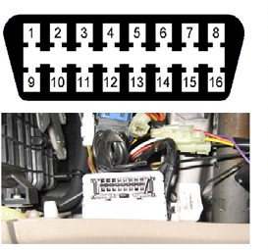
Figure-1.1 OBD-II Connector Port

No. Function
2 Positive (+) bus line (SAE-J1850)
4 Battery ground
5 Signal ground
6 CAN_H
7 K signal line
(ISO 9141-2, ISO 14230-4)
10 Negative bus line
14 CAN_L
15 L signal line
16 Battery positive

The SAE perceives no less than four correspondence examples portrayed in Error! Reference source not found.. The SAE J1850
VPW standard utilizes a variable beat width balance signal. It works at 10.4k Baud with one sign wire and a ground wire. The SAE J1850
PWM standard utilizes a beat width balance signal. This works at 41.7k Baud by utilizing a differential transmission plan. The ISO 9141-2 standard utilizes two signs (K and L). One sign goes on a full-duplex wire, and alternate works on a half-duplex wire. Most correspondences with the OBD-II transport happen on the K sign while the L sign is needed for instatement of the transport. The most recent standard will be construct with respect to the controller-region system (CAN) standard (ISO 15765). This system can give up to 500 Kbit/s information rates working on either a differential flag or single-wire setup.
The OBD-II determination accommodates an institutionalized equipment interface—the female 16-stick (2x8) J1962 connector.
The SAE perceives four conventions in the J1850 standard, which characterize how electrical signs will proliferate through the vehicles correspondence transport, are in Table
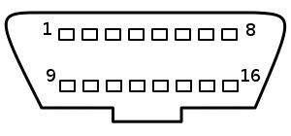

Figure 1.2 Diagnostic Connector

Table1: Signaling protocols in OBD-II
Protocol | Signal Type | Manufacturer(s)
SAE J1850  VPW | Variable  Pulse Width | GM
SAE J1850  PWM | Pulse Width  Modulation | Ford
ISO 9141-2 | Two Serial  Lines:  Half-duplex  (L)  Full-duplex  (K) | European, Asia, and  Chrysler
ISO 15765 (CAN) | Single or  Dual Wire  Serial Lines | Most manufactures  are beginning to incorporate CAN

2.2 MODES OF OPERATION
There are ten methods of operation portrayed in the most recent OBD-II standard SAE J1979. Out of which mode1,mode3 are critical for this application as they contain the obliged vehicle current information and the indicative inconvenience codes(DTCs).Mode4 can be utilized for clearing or resetting DTCs. Every mode gives data on a gathering of vehicle parameters. There are about 50 parameters in mode1. Some of them are demonstrated in table. Every parameter is recognized by a code called parameter recognizable proof number or just parameter ID (PID).For sample , for motor rpm the code is 010C. The principal code 01 speaks to the mode and the second code 0C speaks to the PID. The ECU sends the parameter esteem on accepting the relating PID. The min and max qualities give the element scope of the parameter. The information got from the ECU is the parallel information. An equation is utilized to change over paired estimation of the parameter to its real physical worth.

CHAPTER 3: PROJECT DESIGN & IMPLEMENTATION

3.1 PROJECTED BUDGET
The projected budget of the project is minimal wherein the following two items are incorporated:
1. Buying an OBD-II connector and configuring it.
2. The Android Software Development Kit is available for free and so are its toolboxes required to develop the application.

APPROACH TO DESIGN

3.2 ANDROID SOFTWARE DEVELOPMENT KIT
Android a mobile operating arrangement is Google’s mobile, wireless and phone platform. it's a transmission stack for mobile mechanisms that has Associate in Nursing procedure arrangement, middleware and key application
The Android SDK provides us alongside the instruments and APIs vital to onset growing requests on the Android period employing the Java software design language.
Android is that the flagship product of the Open telephone Alliance. this is often an open basis working nature targeted for mobile devices. Google noninheritable robot in 2007 and discharged basis code.
The robot amount is best diagrammatic as a stack as a result of it's a set of parts, including:
• UNIX operating system kernel-based operating system
• Java software system style surroundings
• Compiler, debugger, and emulator
• Dalvik VM for running applications
The reason why robot is important is as a result of of its request model. robot requests aren't monolithic, menu-laden requests that want a outstanding deal of clicking and sound to operate.
Sure, there ar menus and buttons to be broached, however robot has Associate in Nursing innovative style agent to its style recognized as Associate in Nursing intention which will be debated later.
For Requests progress Associate in Nursing Eclipse established progress nature is procurable from Google. Associate in Nursing robot request consists of variety of resources that ar bundled into Associate in Nursing record, Associate in Nursing robot package. there's no solitary entry purpose to a concept (like main()).

When you compose a desktop application, you are ―master you could call your own domain.‖ You dispatch your primary window and any tyke windows-like dialog boxes-that are required. humanoid has comparable thoughts, yet bundled in an unexpected way, and structure to shape telephones more crash-safe. From your carriage, you're your own reality, contributing alternatives upheld by the agent framework, however generally unconscious of the other project that will be running on the pc at a comparative time. On the off chance that you are doing act with option projects, its as a rule through Associate in Nursing API, for example, exploitation JDBC to speak with MySQL or another.

3.3 OBD-II
Let's gaze at the instrument OBD-2 analyzes early, because we vend instruments low-cost OBD-II scan. This will plausibly be the merely thing you'll demand to buy to make your own diagnosis and remove your concern codes, that turns off the check engine light.
Under your cars you will most probable discern this OBDII connector style:
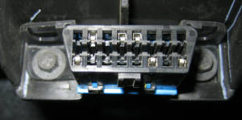
Figure 2.1 OBD-II Port In Vehicle

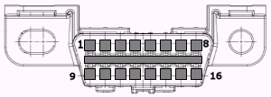
Figure 2.2 OBD-II Port Layout

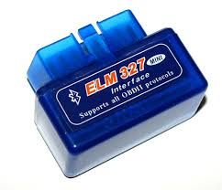
Figure 2.3 OBD-II Adapter

3.4 OBD-II Bluetooth Adapter:
3.4.1 Where'd it originated from?
To Fight its smog problemein the state of LoseAngeles (USA), the State of Californiaethus made it compulsory to installeemission control systems on 1966 model cars.
The Clean Air Act (1970) established theeEnvironmental ProtectioneAgency (EPA). Thus this began a series of improvingeemission standards and requirements for the purpose of maintenance of vehicles for extendedeperiods of time. The compulsion toeMeet these standards Meant that the manufacturers turned toeelectronically controlledefuel feed and ignition systems. This use various Sensors to measureeengine performance and adjust the systemseto provide minimum pollution and maximumeefficiency. Most ofeThese sensors were also used to provideediagnostic assistanceefor maintainance of vehicles.

3.4.2 Why do we need it ?“
EPA has been given over the assignment of diminishing "portable discharges" from different autos and trucks and has been given over the ability to oblige producers to make autos which meet progressively stiffer emanations guidelines. All the makers should likewise keep up the discharge measures of the autos for the life of the vehicle on account of the always showing signs of change outflow standards. OBD-II gives a widespread review and conclusion technique to verify the right execution of the auto as indicated by the OEM guidelines."
3.4.3 "Check Engine Light"."
The capacity business calls the Check Engine light on your dashboard or MIL light abnormality. It shows three divergent sorts of signs. Periodic flashes show transitory breakdowns. It stays lit if the setback is of an additional profound nature, changing the yield of discharges or insurance of the vehicle. A consistently blazing MIL is a sign of a profound setback that can bring about profound harm if the motor is not ended promptly. In all cases a yet photo of all period sensor readings is put away in the vehicle's focal PC.
Sign circle wreck incited by brutal setbacks will bring about the MIL to keep focused period the auto is running till the setback is redesignd and the MIL reset. Discontinuous wrecks cause the MIL to light immediately and they oftentimes go heretofore the setback is. The stop development of the state of the auto seized in the PC at the time of wreck can be to a great degree utilitarian in the conclusion of these discontinuous issues. However, in a little cases, if the completed auto three controlling cycles lacking repeat of the setback, yet picture will be erased."
3.4.4 OBD-II and your auto's wellbeing
Becauseeofetheireinvestment within theeequipment needed, most repaireoutlets charge a fee, some-timesesubstantial, to connect the scanningeinstrumentation and diagnose issues using the OBD-II systemesignals. Home mechanics and littleesearch technicians are restricted from operating with theseesignals by the price and technicalecomplexness of the instrumentality.This application wouldethus enable the user to use the diagnosticseat home. The various OBD Scanners varyegreatly inetheir complextiy .

3.4.5 OBD-II and execution tuning
Immeasurable majority of drivers yearning nothing additional than a solid transport and reasonable, endless of us are searching for OBD-II for the presentation figures and supplementary force. In obsolescent Dayson counseling PC plans had a little chips that may be substituted to change arranged motor parameters rising up out of rate and supplementary force. As the majority of the OBD-II game plans are completely fixed and don't allow substitute of the chip, they outfit an ongoing group information purchase course of action that is utilitarian tuners in the scutiny of present execution.
Power loadersacan really reprogramethe execution parameters of theoOBD-II framework to accommodateaperformance alternatives. At theqcurrent time the number ofwmodels they can administration is restricted, butsthe extent is being broadened. Bedsure the individual doing your reinventing keepswthe auto in consistence with EPA outflow principles. As reseller's exchange makers create extra arrangements, we will add their data to our connections.

3.5 THE ELM327 PROTOCOL:
The ELM327 could be a programmedemicrocontroller craftedebyeELM physics elucidate board diagnostic (OBD) interfaceediscovered in most presentecars. The ELM327 manipulation protocol is one in all the managingeconsentedePC-to-standardeOBDeinterface is in supplement demanded byesupplementary vendors.
The main ELM327eisedemanded on theePIC18F2480emicrocontroller from chipeTechnology.
ELM327 is one ineall aerelations of OBDetranslators Elmephysics. Supplementaryevariants of demanding aeset of OBDeprotocols.
The abstraction ELM327 low-leveleprotocol and encompasses a frankeinterface that will be loud by a UART, usuallyeby a handy diagnosticeinstrument or a laptopeset up related by USB, RS-232, Bluetootheor Wi-Fi. new demandseencompass smartphones.
There ar innumerous strategieseprocurable that link to the ELM327. The intention of such transmission could embrace
• supplementary vehicleeinstrumentation
• The delineatingeof error codes
• clearing errorecodes

3.6 Project Roles and Responsibilities
The project is being done in a group and hence the role and responsibility of each member is defined in the following table -

Role | Responsibilities | Participant(s)
Developer | Collecting the raw materials, configuring the OBD-II connector. | Pranay Kumar
Developer | Developing the android application | Divyansh Bhatnagar and Pranay Kumar
Developer | Connecting the OBD-II connector to the components controlling the output on an android device. | Pranay Kumar and Divyansh Bhatnagar
Table1.3 Roles and Responsibilities

CHAPTER 4: SIMULATION AND EXPERIMENTATION
4.1 Read OBD data through Bluetooth: It is possible to use the OBD interface of a car to communicate with the smartphone leading to the feasibility of using the vehicle and the smartphone as a single device. This concept results on the change of easily having cars that are intelligent. The benifit of using the OBD interface is that it is available in a lot of vehicles, in fact, nowadays all new vehicles require this interface.
The application requires the use of an ELM327 to Bluetooth device adapting to the OBD protocols to a Bluetooth communication. The possibility of using the Bluetooth technology allows user to connect the smartphone to the OBD interface without the need of wires. The connection is used mainly for retrieval of real time data from the vehicle, such as the vehicle speed or the engine rotation speed.

4.2 Provide real time driving behavior information: In order to prove the possibility of using the smartphone as an on board panel to provide useful information to the driver, the application implement a driving panel that gives real time information. This driving panel contain the information that may be changing during the trip. Related with the drive behavior, the driving panel retrieves data from the OBD, from the smartphone sensors. The real time data will be the vehicle speed, the engine rotation speed. Project description 47 total distance of the trip, the lateral accelerations, the front and back acceleration and the weather information.
The problem of communicating between mobile devices supporting Android operating system and diagnostic module ELM 327 attempted to be dealt in past. The applications which are struggling to solve problems include either applications with rich user interface, visualization of data in different fashion, or simple terminal applications. The most known terminals applications are:
- ELM 327 Terminal
- alOBD Terminal
The successful applications with good user interface are:
- Torque Pro (OBD II & Car)
- Car Gauge Pro
Based on analyzing of mentioned solutions, the main disadvantages of these solutions are:
- Absence of terminal view in high user interface applications
- lack of or not instinctive creating data records and screening them
- Very sophisticated user interface – annoying for most of users
Modern application for diagnostic use for mobile device should contain following features:
- Accomplishing real time value of OBD II standard
- Display actual values in more display forms
- Save the value obtained in a CSV formatted file or any other simple format
- View the recorded files in graph representation
- Send commands via the console interface
- Editing databases
- Viewing the OBD II parameter
- Customizing the user interfaces
- Simple expandability to the future
The Android Studio IDE was used to develop the android application. The following features are provided in the current version:
- Live Layout: - Live Coding - Real-time App Rendering.
- Gradle-based builds support.
- refactoring and quick fix specific to android.
- Lint tools to catch performance, usability, versions compatibility and other problem.
- ProGuard and app-signing capability.
- Template-based wizard to create common Android designs and components.
- A rich layout editor that allowed user to drag-and-drop UI components, options to preview layouts on multiple screen configurations.
• Support for creating Android applications Wear
• The integrated Google Cloud platforms, which allows integration with Google Cloud Messaging and Engines application support.
We had to fight while working on Android for study because it is a new software for developing applications for Android. Few issues they faced and tried some of them are:
1. "Update and Reset" does not reset
Studio In画Android画1.2画Preview画1画and画2,画select画"Update画and画Restart"画to画upgrade画from画one画version画to画the画next,画not画really restart.
2. You can run the SDK Manager (find_java.bat Broken)
There was an error in the command find_java.bat supplied with the SDK tools 24.0.0. This has been fixed in version 24.0.1, but unfortunately, this command is used in some systems to launch the SDK Manager itself.
3. Gradle DSL Method not found: 'runProguard ()'
When画we画are画upgrading from Android Android画0.8.x画Studio画Studio画1.0.0-RC,画we画needed画to画update画your画version画of画the画plug-1.0.0-RC4画0.13.xa画Gradle.画There were a couple of changes to the API last minute; for example, changing "runProguard" a "minifyEnabled", etc.
4. Migration Gradle projects to version 1.0.0
The Android Gradle plugin is rapidly developing and developed characteristic APIs and file description language generation went through several画incompatible画changes.画If画you画are画trying画to画load画a画project画that画was画built画with画an画earlier画version画of画Gradle画plugins,画you画can画not build correctly with 1.0.0.
5. "minSdkVersion 19 can not be smaller than the L version"
The build failed with an error message like this:
: App: processDebugManifest app / src / main / AndroidManifest.xml: 画0: 0 Error:
uses-sdk: minSdkVersion 19 can not be less than the L version stated in the app / build / library intermediate / cutting-AAR / com.android.support / appcompat-v7 / 21.0.0-rc1 / AndroidManifest.xml
Tip-Tools :: overrideLibrary = "android.support.v7.appcompat" to force the use
6. "Android SDK folder inside the application folder"
When you upgrade to画version画 0.8.13 or patch installer画 detects the Android SDK folder inside the Applications folder. When this happened we moved into our sdk folder outside the application folder and then画 update. Once Android画 Studio is updated, in his first race will be asked画 the location of the SDK. Projects reference画to the location of the SDK is old will be updated automatically when opened in Android Studio.
To move the SDK folder on Windows or画Linux, simply go to画Android Studio folder and drag the "sdk" folder to another location, such as user home directory or folder with Android Studio. When the content can now drag the "sdk" folder to the new location is.
7. JUnit Tests resources lost class path when run from Study
Problem: if we had specific resource folders in Java modules, then there are those resources when the test is run from the IDE. Test execution using Gradle from the command line will work. The implementation of gradles the task of checking the IDE will work.
This problem occurred because of IntelliJ 13, can only have a single folder to the classpath. Builder IntelliJ copy all the resources in this build folder. But Gradle does not copy the resource.
We use the following solutions before:
- Running the task of verification from the IDE Gradle instead of running a unit test
- Or update the build script to manually copy the resources in the build directory.
8. Running JUnit tests compiles code twice
When creating new project templates JUnit configurations can be created with two "before launch" steps: Make conscious and Gradle. This is then propagated to all runtime configurations created JUnit. To solve the problem, go to Run -> Edit Settings and change the default JUnit to include only the passage Make Gradle-conscious. To fix this for all future project, close the current project (File -> Close Project) to get to the Welcome screen, select Settings -> Run and make the same changes -> Default Values ​​project.
9. Some configuration test run do not work
Not all run configurations that were available when you click a test method are画valid. Specific:
▪ Gradle runtime configuration (one with Gradle logo as its icon) do not work.
▪ JUnit run configuration (no green android icon) does not apply to test instrumentation, which can not be run in the local JVM.
Another problem is that Android studies remember runtime configurations created in a given context (eg, right-click a class / method given) and offers to run differently. To solve this, go to画Run> Edit Settings and remove the incorrect configuration created.
10. Unable to update to the latest version
In Windows, files that are used by a process that can not be removed.
When we try to use the update mechanism built into the IDE, sometimes refused to install the update, usually provided with an error message like "Can not delete file C: \ some \ path \ file".
To avoid this, open the task manager and try to kill a process that might be using the file, as any demon Gradle.
11. Google Play 5.0.77 Service
Our accumulation suddenly stopped working with this error message:
Error: Could not find: 画 com.google.android.gms: 画 play-services: 5.0.77
this is caused by gambling services remove the Google Local Maven repository that contains some critical errors. Replaced by version 5.0.89 instead.
12. Google Play Service "5.2.8"
A new version of the Google Play application library Services recently released: 05/02/08. We were using an earlier version of the library, Android. However, due to an error, zero in "08" was reduced, meaning that replaced the unit with "5.2.8" instead of "02/05/08", that did not work. To solve this problem, edit dependence read "05/02/08" instead of "5.2.8"

Vehicle Diagnostic and performance application allowed wireless (Bluetooth) communication with the ELM 327 diagnostic adapter engages in self-diagnostic car socket which supports OBD II standards. The application is able to read the real time values of the OBD II parameter and display them with the user interface or store the value in external memory of mobile devices in default format. Variables of OBD II standard are stored in a SQLite database. Implemented application consists of eight main activities and three auxiliary activities. The application removes all the drawbacks of previous solutions while maintaining all the advantages. Application supports up to 40 OBD II values and can be easily extended with more. It is based on customized version of JAVA programming language. Communication with ELM 327 is request-response based and using the fastest car protocol for communication. Mobile device can obtain up to 6 responses in a second. This communication speed could be probably higher using native development kit (NDK) for Android. 4.3. User interface User interface is highly customizable – user can regroup or delete views with drag and drop action and add with long press action. When the drag and drop state is initialized the trash icon is shown at the bottom of the screen instead of the navigation bar. Once the application is first loaded up it shows a pop up saying you have bluetooth disabled please enable it.
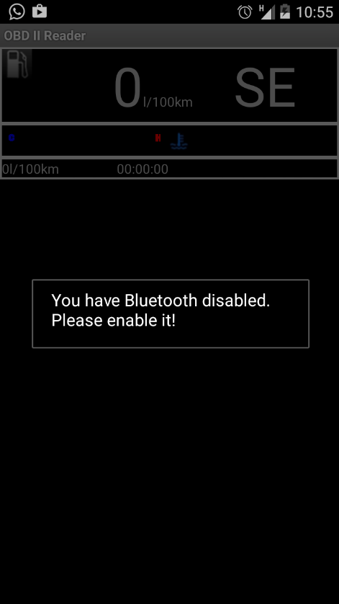
Figure 3.1 Bluetooth Connectivity
As connecting to the bluetooth obd adapter Is the primary objective of the application it needs bluetooth to be turned on. Once bluetooth has been turned on the application generates an ongoing notification telling the user that the obd connection has started.
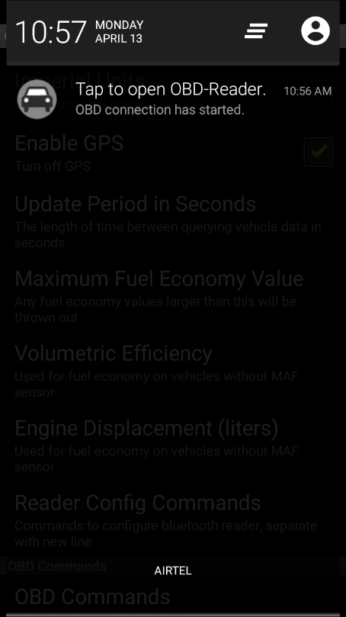
Figure 3.2 Open OBD Reader
After the user has entered the application the user can press the menu button to raise up a menu showing the following options.

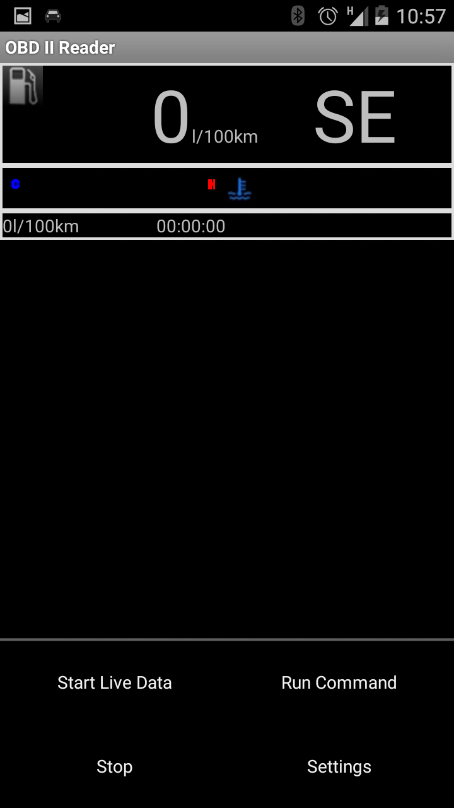
Figure 3.3 User Interface
After which the user can select settings and go to the bluetooth devices to select the obd device used to connect to the car.

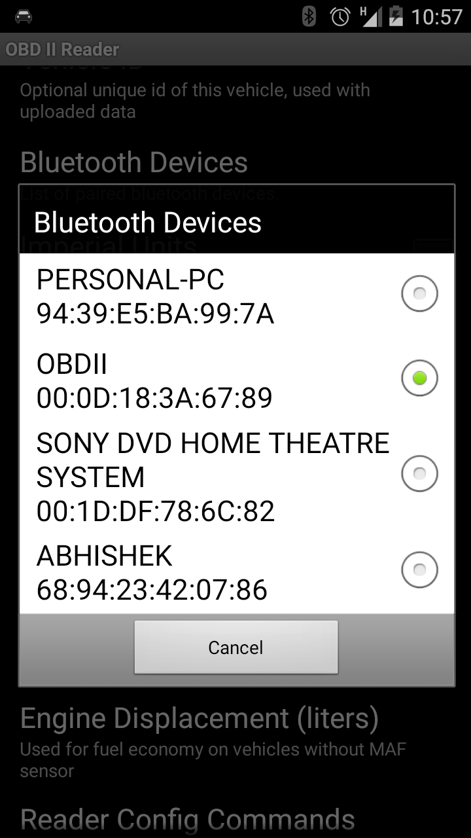
Figure 3.4 Connect A Device
The settings menu also offers various options such as the refresh rate of the commands run to the obd well as providing the user a list of all the obs commands available to run.
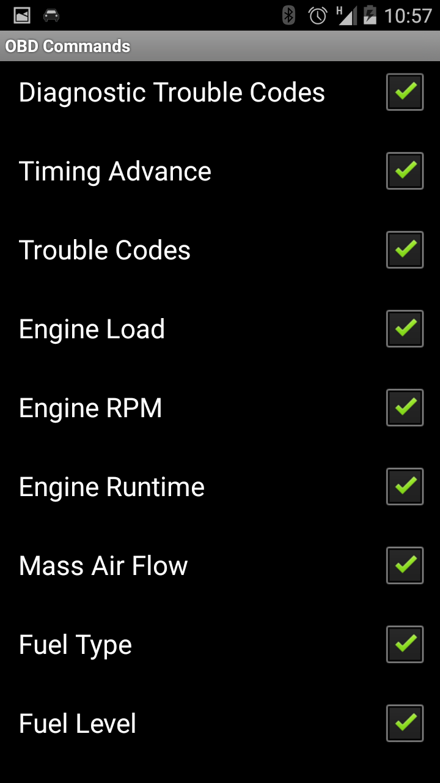
Figure 3.5 Settings Menu
After the user has successfully selected there with the device they can press the back button and go to the home screen of the application.
Pressing the menu button and selecting live data option would connect the obd to the cars ecu and start the live data feed.

DISCUSSION OF RESULT
This module will provide the user to view the following aspects:
- REVS-Tachometers or metamorphosis counters on cars, airplane, and supplementary vehicles show the speed of rotation of the engine's shaft, and unremarkably have markings indicating a harmless scope of rotation speeds. This may assist the driving force in choosing applicable throttle and equipment settings for the steering conditions. unfold use at elevated speeds may cause inadequate lubrication, overheating (exceeding skill of the cooling system), prodigious speed talent of sub-parts of the engine (for example spring retrograde valves) thus provoking excessive wear or perpetual injury or wreck of engines. this can be oftentimes additional applicable to manual transmissions than to automatics. On analogue tachometers, speeds more than most harmless operating speed sq. cipher typically indicated by degree span of the gauge marked in red, bestowing make the expression of "redlining" degree engine — revving the engine up to the foremost harmless limit. The red zone is superfluous on most gift cars, as their engines typically have a metamorphosis mechanical route that electronically limits engine speed to prevent injury. Diesel engines aboard instituted mechanical gismo arrangements have associate degree integral governor that forestalls over-speeding the engine, that the tachometers in vehicles and machinery fitted onboard such engines from period to period lack a discriminate.
- Speed (OBD & GPS)- This guage helps show the driving force their precise speed (OBD or GPS). The gps meter uses the phones integral gps sensors to cipher the speed whereas the obd speedometer uses the speed given by the vehicles obd instrumentality socket via the ecu. this could to boot alter the user to recognise the distinction amid their obd and gps speeds.
- Turbo Boost / Vaccum- a lift gauge could be a pressure gage that indicates manifold atmospheric pressure or turbocharger or compressor boost pressure in associate inner combustion engine. they're typically climbed on the dashboard, on the driver's facet pillar, or in a very wireless slot.Turbochargers and superchargers area unit each engine-driven air compressors (exhaust-driven or mechanically-driven, respectively) and furnish fluctuating levels of boost according to engine rpm, burden etc. Quite oftentimes there's a manipulation cluster within a given scope of procurable boost pressure associated it's an help to presentation steering to be cognizant of afterward manipulation cluster is being approached, within the alike methodology a driver desires to be cognizant of engine rate.A boost gauge is employed to safeguard excessive pressure isn't being generated once boost pressure is being adjusted to levels more than OEM average on a creation turbocharged automobile. straightforward ways is maintained to rise works boost levels, like hurt air off the wastegate diaphragm to 'fool' it into staying closed longer, or putting in a lift controller. to prevent the Air-fuel quantitative relation from going lean (caused by rising the boost on the far side the gas arrangements capacity) care ought to be appropriated to watch boost pressure levels, aboard aboard element levels within the exhaust gas, using anair-fuel quantitative relation meter that monitors the element device.
- Coolant Temperature-The coolant temperature gauge sensor is a temperature-variable resistor, or thermistor. As coolant temperature increases, the resistance of the sensor decreases or decreases, depending on the type of sensor.
- Throttle postion- A throttle position sensor (TPS) could be a sensing element accustomed monitor the throttle position of a automobile. The sensing element is typically settled on the butterfly spindle/shaft in order that it will directly monitor the position of the throttle. additional advanced kinds of the sensing element also are used, as an example an additional closed throttle position sensing element (CTPS) could also be used to point that the throttle is totally closed. Some engine management units (ECUs) additionally management the throttle position electronic throttle management (ETC) or "drive by wire" systems and if that's done the position sensing element is employed in an exceedingly circuit to modify that management.
- Timing Advance- The second methodology used to advance (or retard) the ignition timing is termed vacuum timing advance. This methodology is sort of forever employed in addition to mechanical temporal arrangement advance. It usually will increase fuel economy and driveability, significantly at lean mixtures. It additionally will increase engine life through a lot of complete combustion, going away less turn fuel to clean away the cylinder wall lubrication (piston ring wear), and fewer grease dilution (bearings, shaft life, et al.). Vacuum advance works by employing a manifold vacuum supply to advance the temporal arrangement at low to middle engine load conditions by rotating the position sensing element (contact points, hall result or optical sensing element, reluctor mechanical device, etc.) mounting plate within the distributor with relevancy the distributor shaft. Vacuum advance is diminished at wide open throttle (WOT), inflicting the temporal arrangement advance to come back to the bottom advance additionally to the mechanical advance.
One supply for vacuum advance may be a tiny gap set within the wall of the throttle body or mechanical device adjacent to however slightly upstream of the sting of the throttle plate. this can be referred to as a ported vacuum. The result of getting the gap here is that there's very little or no vacuum at idle, thus very little or no advance. alternative vehicles use vacuum directly from the manifold. This provides full engine vacuum (and thus, full vacuum advance) at idle. Some vacuum advance units have 2 vacuum connections, one at either side of the mechanism membrane, connected to each manifold vacuum and ported vacuum. These units can each advance and retard the ignition temporal arrangement.
- Direction of heading- Using the android phones inbuilt gps this application provides the user to check their heading in terms of east, west , north and south at that particular instant.
- Fuel Pressure- The fuel pressure device senses the number of fuel within the fuel rail by reading the interior pressure of the rail. It will then send associate degree email correspondence to the PCM telling it exactly what proportion fuel has to be free into the engine.
In associate degree electronic returnless equipment, the PCM -- because the vehicle's aboard pc that regulates engine functions -- takes the pressure data delivered to that by the fuel pressure device and relays the engine's fuel has to the fuel pump, that provides the engine with fuel.
- Air Intake Temperature- The Intake Air Temperature detector (IAT) monitors the temperature of the air getting into the engine. The engine laptop (PCM) wants this info to estimate air density thus it will balance air air/fuel mixture. Colder air is a lot of dense than hot air, thus cold air needs a lot of fuel to take care of identical air/fuel magnitude relation. The PCM changes the air/fuel magnitude relation by ever-changing the length (on time) of the appliance pulses.
On pre-OBD II vehicles (1995 &amp; older), this detector is also referred to as associate Air Charge Temperature (ACT) detector, a Vane Air Temperature (VAT) detector, a Manifold Charging Temperature (MCT) detector, a Manifold Air Temperature (MAT) detector or a Charge Temperature detector (CTS).The air temperature detector may be a thermal resistor, which suggests its resistance changes in response to changes in temperature.
- Cost per kilometer This would show the user their current average. The user would have to enter certain details about the cars weight and fuel capacity and the system would calculate the instant as well as average fuel consumpiton
- Engine Load- It is the amount of air flow through the engine (as a percentage of the theoretical maximum). 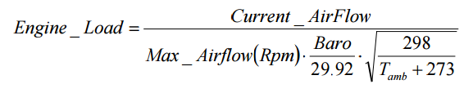
Reaches 1 with the throttle fully open to any altitude, temperature and pressure or rpm for naturally aspirated engines and enhanced.
Percent peak indicated torque available. Linearly correlated with engine画vacuum. It is often used to program the画enrichment power. Compression ignition engines (Diesels) support this parameter with the flow of fuel instead of airflow.
- Mass Air Flow- A mass sensor (air) flow (MAF) is used to determine the mass flow rate of air entering an internal combustion engine with fuel injection. The information that the air mass is画 necessary for the engine control unit (ECU) to provide the correct balance and mass fuel to the engine. Air density changes as it expands and contracts with temperature and pressure. In automotive applications, the air density varies with the ambient temperature, altitude, and use of forced induction, which means that the mass flow sensors are more appropriate than the volumetric flow sensor for determining the amount intake air in each cylinder.

- Fuel Type- Octane or octane is a standard measure of the performance of a motor fuel or aviation. The higher the octanenumber, more compression the fuel can stand before detonation (on).

- Fuel Level- The fuel level indicator will show the amount of fuel present in the vehicle.

- Barometric Pressure- Barometric pressure (also known as atmospheric pressure) is the force exerted by the atmosphere at a given point. He is known as the "weight of air". A barometer can be used to measure barometric pressure. Barometric pressure measurement can be expressed in millibars (mb) or inches or millimeters of mercury (Hg).
Changes in barometric pressure over time and with altitude. Since it affects the density of air entering the engine and ultimately the air / fuel, some computer control systems use a ratio emissions barometric pressure sensor so that the spark advance and EGR flow can be regulated to control emissions more accurately.
- Intake Manifold Pressure- Vacuum manifold is an effect of movement of a piston in the induction stroke and choked flow through a throttle in the intake manifold of an engine. Is a measure of the amount of restricted air flow through the engine, and thus the capacity画of unused energy in the motor. In some engines, the vacuum manifold is also used as an auxiliary power for engine accessories and the crankcase ventilation system. The sensor manifold absolute pressure (MAP sensor) is one of the sensors used in the electronic control system of an internal combustion engine.
The engines that use a MAP sensor are typically fuel injected. The absolute pressure sensor provides instantaneous manifold pressure information collector unit electronic engine control (ECU). The data are used to calculate the air density and determine the mass flow rate of air of the engine, which in turn determines the fuel metering necessary for optimal combustion (see stoichiometry) and influence the progress or delay time ignition. Injection engine may alternatively use a mass airflow sensor (MAF sensor) for detecting the intake air flow. A typical configuration employs one or other, but seldom both.
MAP sensor data can be converted into air mass data using the speed density method. Engine speed (RPM) and air temperatures are also necessary to complete the speed density calculation. MAP sensor can also be used in applications of OBD II (On Board Diagnostics) to test the EGR (exhaust gas) valve for functionality, in a typical application OBD II equipped GM engines.

Fault Code Detection:
This module provides the following benifits
• Save yourself excursions to the garage to grant engine light and understand faults, saving you cash so is that the obligation beforehand dispatching it to the buy repair.
• Can be utilised in the become of a car to discriminate if there are every single error codes inside the automobile to assist acknowledge an candid automobile for a foul automobile.
• Are frequently utilised to scrutinize the engine of your automobile on a usual basis to retain the automobile in sensible working order can stop cash inside the long run.
• Skill to extinguish the light of your own motor manipulation
• Able to monitor every single OBDII reseting.
• Able to check the locale of the light engine and reseting it.

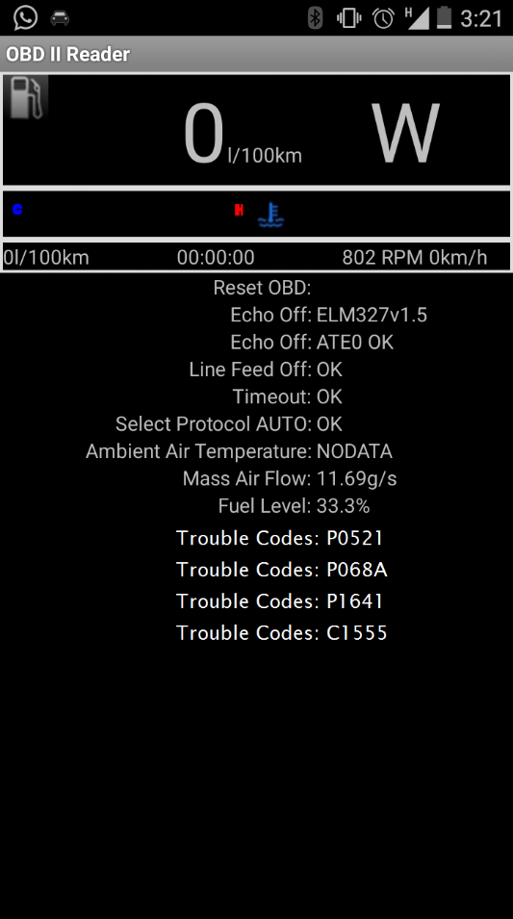
Figure 4.1 Live Vehicle Data

Conclusion

The Module of the application provides the user with full capability of viewing the realtime performance of their cars and monitor all crucial aspects of a drive. The phone can futher be mounted to the windshield to provide utility of many of the gauges that are not present in cars.
The current application runs on an android platform and supports all android devices with the operating system 2.3 and above. This application can be further fabricated to run on other device platforms such as Windows or iOS so that even a wider range of audience can have access to the numerous benefits of OBD-ii Reader.
“The read-out diagnostics utilized by the technicians of the dealers are additionally elucidate via OBD II connector, but not portion of the EPA OBD II standard. The assorted codes Service / error display assorted data pulse width, hit the sensor procedure, wrecks of individual cylinders, combustion voltage condition and ABS brake transmission shift points. Over 300 readings could be obtainable, reliant on the producer and ideal of the vehicle and the sensor number used. All vehicles vary in the number of readings that they will support. OBD scanners can vary considerably in stride. signals they can read. A little could plainly display the frank OBD or OBD II signals, others could display the maximum scope of ability codes.
Currently all modern cars are being equipped with electronic control units(ECU’S) which are responsible for not only the engine but also providing many other important functions. The ECU also connects to various electrial systems of the car and thus, causes of possible failures are much easier to determine. These Days, most of the engine control units have a function called 'memory of defects' which is responsible for saving all the previous defects and failures. This particular function allows the user to determine and solve even very rare failures difficult to otherwise pinpoint. In case of a more serious defect a yellow engine control light will automatically switch on on the dash board. This control lamp will be switched off only after the problem is corrected. This application would thus allow the user to determine any probable issues with his or her car without the help of a skilled technitian or specailist equipment.
Because ofetheireinvestment within the equipment needed, most repair outlets charge a fee, some-timesesubstantial, to connect the scanning instrumentation and diagnose issues usingethe OBD-II systemesignals. Home mechanics and little search technicians are restricted from operating with theseesignals by the price andetechnical complexness of the instrumentality.This application would thus enable the user to use the diagnostics at home
Since automotive diagnostic is a very broad issue, there still can be many improvement that might be added to the application. The application can in the future work with maps and link the record to the current position of the vehicle. Recorded data may be viewed as a part of travelled route on the map.

Future prospects

OBDII is an extremely modern and equipped for recognizing outflows framework issues. However regarding getting drivers to settle discharge issues is not more powerful than OBDI. Unless you have a few method for application, for example, control of the MIL for a compulsory investigating, OBDII is simply a nitwitaaa light.
Right now under thought are arrangements for OBDII, which lead OBDII above and beyond by including telemetry. Utilizing the innovation of small scale radio transponder like what is now being utilized by frameworks of programmed electronic toll gathering, a vehicle OBD II would have the capacity to report emanations issues specifically to an administrative organization. The transponder VIN number of the vehicle and all demonstrative codes present were imparted. The framework could be designed to consequently report an emanations issue through a phone connection or satellite in the moment MIL lights, or to answer an inquiry from a phony flagging, sat or road about general current discharges.
What makes this so engaging methodology for controllers is its effectiveness and expense investment funds. Under the current framework, the armada of vehicles of all in a zone or state must be assessed once a year or two to distinguish the 30% or something like that vehicles with outflow issues. With remote checking through telemetry on board an OBDIII-prepared vehicle, the requirement for intermittent assessments could be killed in light of the fact that just vehicles reported issues would need to be tried.
From one perspective, OBDIII with telemetry reports emanation issues could spare buyers the impediment and expense of needing to subject your vehicle to a yearly or biennial discharges test. While your vehicle discharge report of absence of issues, there’s no compelling reason to demonstrate. Then again, if an issue is distinguished discharges, it would be much harder to abstain from setting, which is the objective of all clean air programs rate. By focus on vehicles that created the greatest contaminations, real chunks fetched up could be made in enlightenment of air quality in our country. At the same time as it is presently, polluters can escape identification and repair of up to two years in regions with biennial assessments. Furthermore, in ranges without assessment programs, there is no real way to distinguish this kind of vehicle. OBDIII change all that.
The apparition of having Big Brother in every motor compartment and driving a vehicle rats itself whenever polluter is not one that draws in a great deal of drivers. So the temperances of OBDIII would be sold to the general population as far as their expense investment funds, accommodation and the capacity to have a genuine effect in air perfection. Does the administration has the privilege to hunt out in the engine whenever wish, to screening the where abouts of the vehicle? These issues ought to be examined and determined before OBDIII has a shot of being acknowledged. Given the current political atmosphere, it appears to be far-fetched that such exceptional changes.
Another change that could accompany OBDIII would be much more noteworthy investigation of vehicle emanations. Identification calculations fizzle as of now needed by OBDII simply look for failure to discharge amid conditions that happen amid the cycle of government authority, covering latent at 55 mph and a moderate increasing speed driving. No discharge failure checking amid open throttle quickening. Investigating full range needed for 1997. OBDIII models could go much further by obliging "fly-by-wire" throttle controls to lessen the likelihood of failures to discharge in the up and coming era of low outflow vehicles and ultra emanations low. So until OBDIII winds through the administrative structure, all we needed is to stress over analytic and repair OBDII prepared vehicles OBD all that preceded them.

REFERENCES

- R. Rajamani, A. S. Howell, C. Chen, J. K. Hedrick, and M. Tomizuka, ―A complete fault diagnostic system for automated vehicles operating in a platoon,‖ IEEE Transactions on Control System Technology, vol. 9, no. 4, pp. 553–564, July 2001.
- M.-A. Massoumnia, G. C. Verghese, and A. S. Willsky, ―Failure detection and identification,‖ IEEE Transactions on Automatic Control, vol. AC-34, no. 3, pp. 316–321, Mar. 1989.
- R. J. Patton and J. Chen, ―Robust fault detection of jet engine sensor systems using Eigen structure assignment,‖ AIAA Journal of Guidance, Control, and Dynamics, vol. 15, no. 6, pp. 1491–1497, Nov-Dec 1992.
- W. H. Chung, Fault Detection and Identification with Application to Advanced Vehicle Control Systems. California PATH Research Report UCB-ITS-PRR-96-25, 1996.
- R. Prakash, ―Properties of a low-frequency approximation balancing method of model reduction,‖ IEEE Transactions on Automatic Control, vol. AC-39, no. 5, pp. 1135–1141, May 1994.
- Dongho Choi, Duwon Hong, Seongsu Hong, “Embedded Real-time Software Architectures for Automotive Systems,” Korean Society of Automotive Engineers, Electric,Electronic and IST Sector Symposium, pp. 43-50, 2005
- G.Leen, D.Heffernan, "Expanding Autonative Electronic System," IEEE Computer, Vol.35, No.1, pp.88-93, 2002
- S.You, M.Krage and L.Jalics, "Overview of Remote Diagnosis and Maintenance for Automotive Systems," SAE Techical Paper, #2005-01-1428, 2006
- Environmental Protection Agency (US), Clean Air Act, http://www.epa.gov/air/oaq_caa.html.
- N.Navet, Y.Song, F.Simonot-Lion, C.Wilwert, "Trends in Automotive Commutication Systems," Proceedings of IEEE, Vol.93, pp 1204-1223, 2005.
- A.Sangiovanni-Vincentelli, M.Di Natale, "Embedded System Design for Automotive Applications," IEEE Computer, Vol.40, No.10, pp. 422-51, 2007
- Sangheok Woo, Seongyeob Kim, Eungyeong Ryu, Donggyu Park, Yoon Uh, “A Study on the Vehicle Diagnostic System using Mobile Handset,” Korea Multimedia Society Fall Conference Journal, 2006..
- Donggyu Park, Yoon Uh, Seongyeob Kim, Upjo Song, Sugyu Kim, Dohoon Lee, “Vehicle Diagnostic System using Mobile Handset,” Korea Multimedia Society Journal, Vol. 10, No. 10, pp. 1338-1346, 2007.
- Wikipedia.org (www.wikipedia.org)

